**EXPNO4:LIBRARY MANAGEMENT**

**AIM:** Create a simple cloud software application for Library Management System using any Cloud Service Provider to demonstrate SaaS.

**PROCEDURE:**

**step1:** Go to zoho.com.

**step 2:** Log into the zoho.com.

**step 3:** Select one application step.

**step4:** Enter application name as library book reservation system.

**step 5:** Created new application as library book reservation system.

**step 6:** Select one form

**step 7:** The software has been created.

**IMPLEMENTATION:**

**Step 1:**

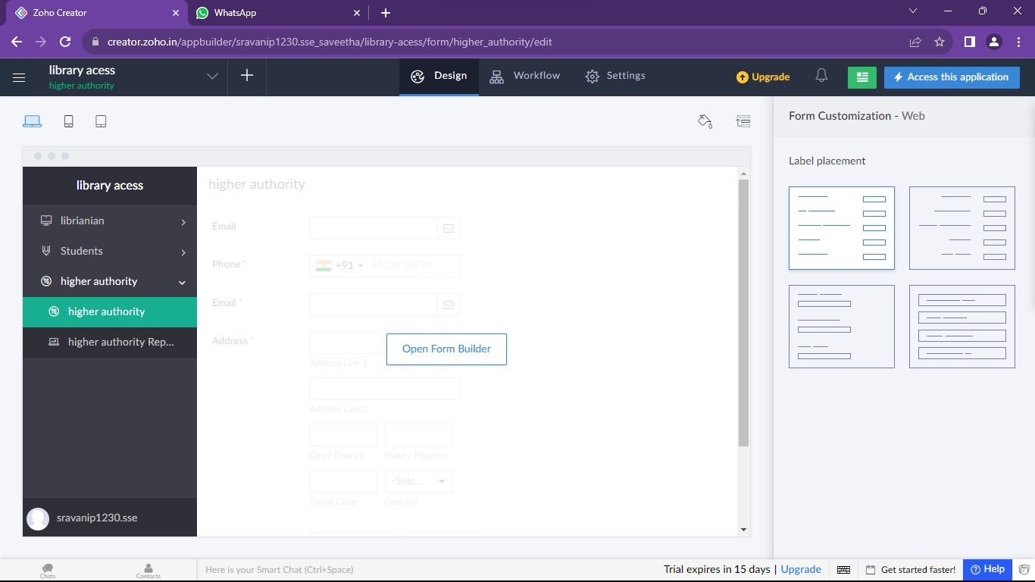

**Step 2:**

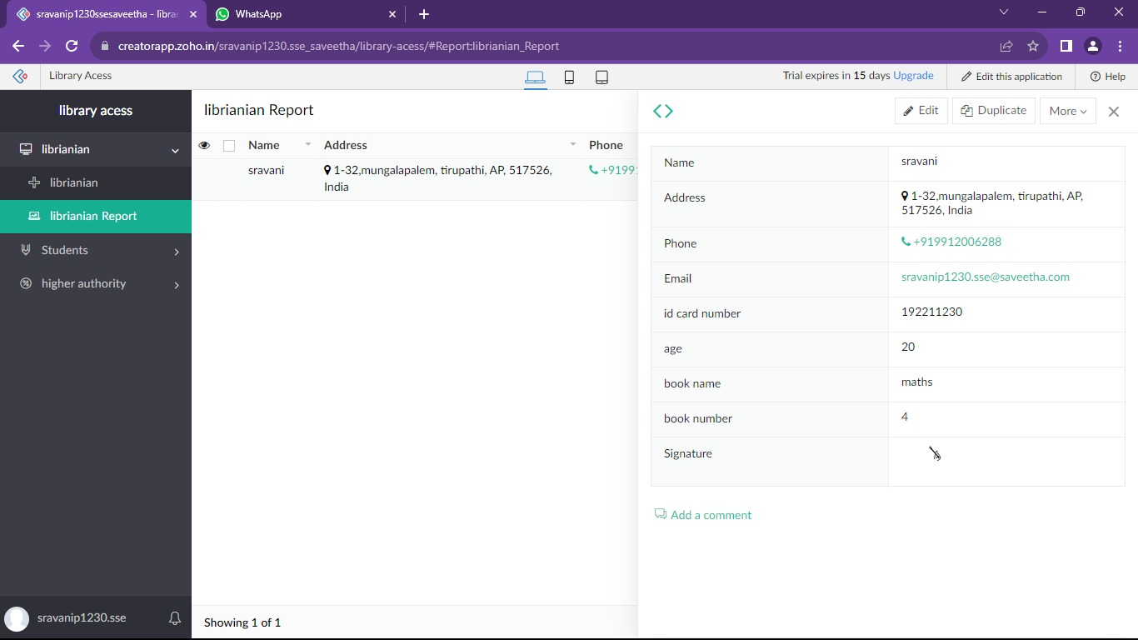

**Step 3:**

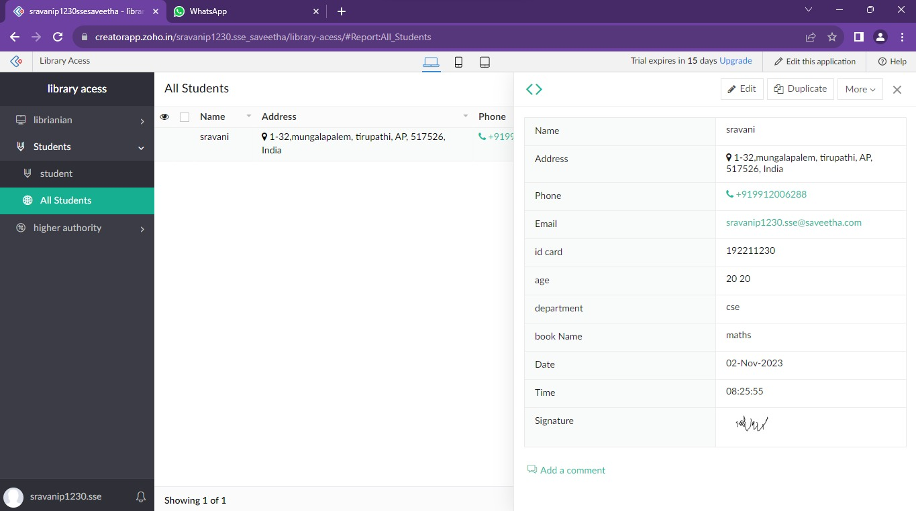

**Step 4:**

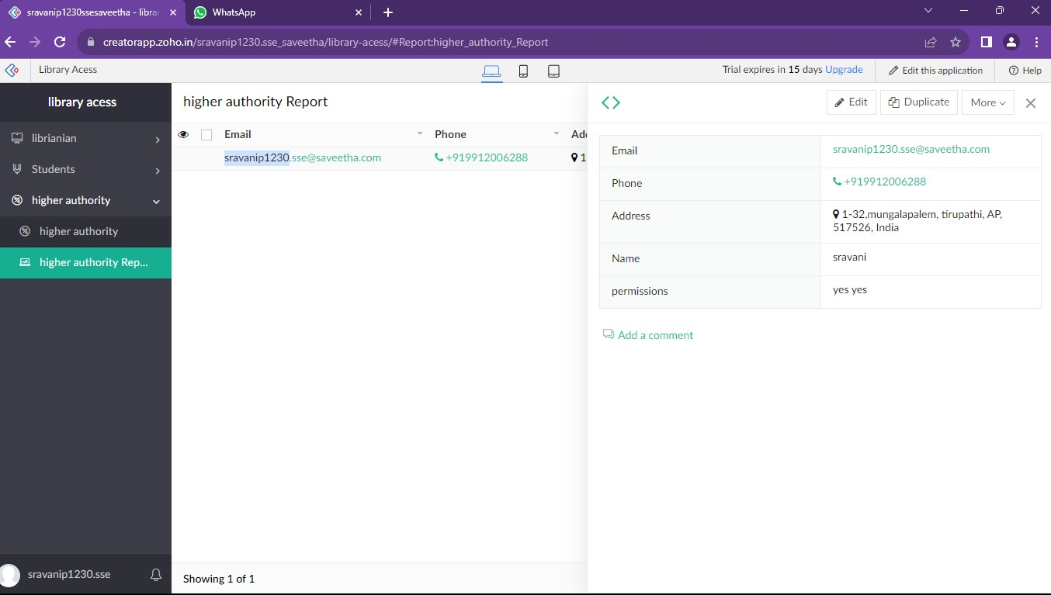

**Result:**

Successfully Developing a library management system with Zoho ensures scalable, secure, and integrated solutions for seamless user experiences**.**